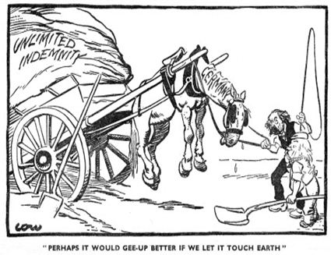
A British cartoon published in September 1919.

- Who does the horse represent?
- Who is trying to get it to go (gee up)?
- Why can’t it go anywhere, what impression do you get of the horse?
- Why would a British person make this cartoon, did they think the T of V was fair?

